**RATHNAVEL SUBRAMANIAM COLLEGE OF ARTS AND SCIENCE, (AUTONOMOUS), SULUR, COIMBATORE – 641 402 POST GRADUATE AND RESEARCH SCHOOL OF COMMERCE**

**SUBJECT: MICRO ECONOMICS DATE: 5th AUG 2023 TOPIC: OPPORTUNITY COST, PRODUCTION POSSIBILITY CURVE SECOND WEEK: Quiz, Activities (Individual, Group) and Assignments QUIZ – In Google Classroom**

**INDIVIDUAL ACTIVITIES**

1. In each of the following cases, consider what might be the opportunity cost. a. A person wanting to buy fruit, but decides to buy apples b. A person decides to study economics at a university c. A factory is built on farm land d. A woman has a television set which cost her $800 two years ago. A new set would cost her $1000 and she could sell her television set for $450. What is the opportunity cost of keeping the old television?
2. Look at the graph and answer the questions.

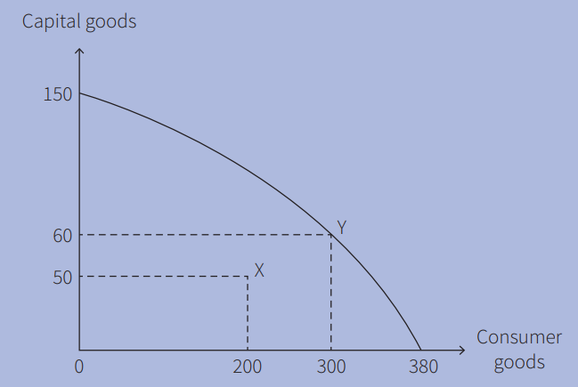

Fig. A country’s PPC

1. If a country is producing at point X, what is its output of capital goods and consumer goods?

2. If a country’s output moves from point X to point Y, how many more capital goods and how many more consumer goods will it produce?

3. What is the maximum number of capital goods that can be produced if all resources are devoted to capital goods?

1. Using Figure,

1 State the maximum number of capital goods the country can produce if it devotes all of its resources to making capital goods.

2 Calculate the opportunity cost of increasing the output of consumer goods from 80 to 90 units.

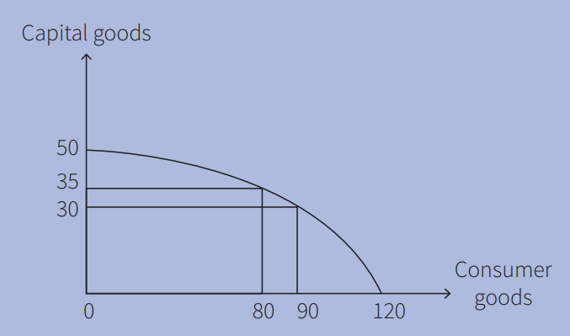

Fig. A country’s PPC

**GROUP ACTIVITIES**

1. In your group, discuss why the opportunity cost of working as an accountant is likely to be higher than that of working as a window cleaner.
2. In your group, discuss and decide whether the following will cause a shift of a country’s PPC to the left or the right: a advances in technology b a rise in the retirement age c improved education d widespread floods e worn out capital goods not being replaced

**ASSIGNMENT QUESTIONS**

1. On his birthday, Kamran receives $200 from his aunt, $50 of which he decides to save. He is taken out by his father for lunch. His father pays the bill. Kamran spends the afternoon playing football. Which of these activities involves an opportunity cost?

|  |  |  |  |
| --- | --- | --- | --- |
|  | Eating the free lunch | Playing football | Saving |
| A | NO | NO | NO |
| B | NO | NO | YES |
| C | NO | YES | YES |
| D | YES | YES | YES |

1. Four firms can produce soap and perfumes. The table shows the maximum number of bars of soap and bottles of perfumes, thjat each firm can make each day if they specialize in one type of products.

|  |  |  |
| --- | --- | --- |
|  | Bars of soap | Bottles of perfume |
| Firm W | 50 | 10 |
| Firm X | 60 | 12 |
| Firm Y | 64 | 16 |
| Firm Z | 90 | 20 |

1. Which type of factors of production are a football stadium and an owner of a football club?

|  |  |  |
| --- | --- | --- |
|  | Football stadium | Owner of a football club |
| A | Capital | Entrepreneur |
| B | Capital | Labour |
| C | Land | Entrepreneur |
| D | Land | Labour |

1. A firm employs 26 workers, paying each one $75 a week. What is the Firm’s total wage cost? A country produces $900 million capital goods in a year. There is depreciation of $620 million. What is net investment?
2. Draw a production possibility curve showing the effect of an increase in the quantity of resources.